POLITICAL JUGGERNAUTS : A QUATITATIVE ANALYSIS IN THE 2019 LOK SABHA ELECTIONS

1 INTRODUCTION

1.1 OVERVIEW

The Lok Sabha is composed of representatives of people chosen by direct election on the basis of Universal Adult Suffrage. The Constitution of India allows for a maximum of 550 members in the House, with 530 members representing the States and 20 representing the Union Territories. The 17th Lok Sabha was formed by the members elected in the 2019 Indian general election. Elections, all across India, were conducted in seven phases from 11 April 2019 to 19 May 2019 by the Election Commission of India.

1.2 PURPOSE

The Bharatiya Janata Party received 37.36% of the vote, the highest vote share by a political party since the 1989 general election, and won 303 seats, further increasing its substantial majority. In addition, the BJP-led National Democratic Alliance (NDA) won 353 seats.

2 PROBLEM DEFINITION & DESIGN THINKING

2.1 EMPATHY MAP

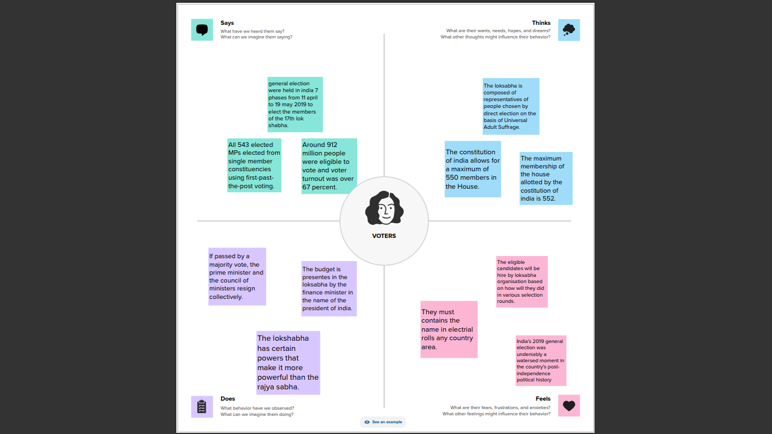

2.1 IDEATION & BRAINSTORM MAP

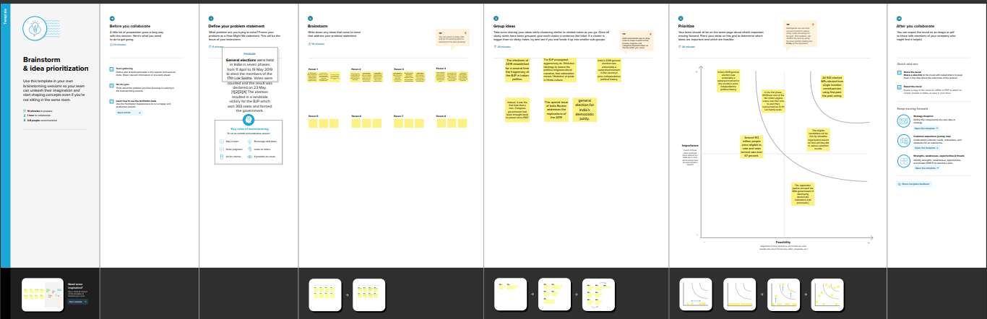

3 RESULT

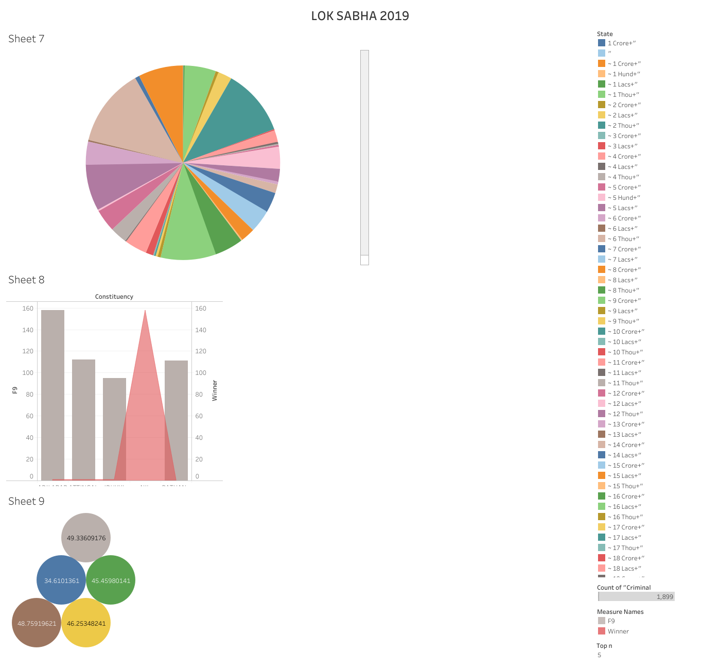

4 ADVANTAGES & DISADVANTAGES

ADVANTAGES OF LOK SABHA

The Lok Sabha is the lower house of parliament of India. The members of the lok sabha are elected by the universal adult suffrage. The tenure of the lok sabha is 5 years. In practice, the Lok Sabha is more powerful than the Rajya Sabha.

DISADVANTAGES OF LOK SABHA

  There is no **disadvantages** with the **Loksabha**. There are some problems like disruption of the proceedings by Congress members and other members.

5 APPLICATIONS

Legislative assembly in the states of Andhra Pradesh, Arunachal Pradesh, Odisha and Sikkim were held simultaneously with the general election, as well as by-elections of twenty-two seats of the Tamil Nadu Legislative Assembly.

6 CONCLUSION

The average of assets of winners in the Lok Sabha elections is Rs 20.9 crore. There are 266 MPs whose assets are Rs 5 crore or above. The number of crorepati MPs elected in 2009 and 2014 were 315 (58 percent) and 443 (82 percent), respectively.